**UNIVERSITY OF GREENWICH**  
COMP-1640-M02-2022-23 Enterprise Web Software Development - Individual Report

Coursework

|  |  |
| --- | --- |
| Student name | TO NHAT DUY |
| ID number (00xxxxxxx) | 001272680 |
| Lecturer/Tutor name | LE THANH HUY |
| Student submission date | April 19th 2023 |

**Team name:**

## Team member + Positions + Commitment point

**Table 1:** Team members - Roles

|  |  |  |  |
| --- | --- | --- | --- |
| **Member’s name** | **ID** | **Roles** | **Commitment point**  **(0-10)** |
| To Nhat Duy | 001272680 | Database Designer – Tester |  |
| Truong Van Phat | 001272727 | Product owner - tester |  |
| Nguyen Huynh Hong Quan | 001272731 | Tester - Backend Developer |  |
| Tran Quan Vinh (Leader) | 001272758 | Scrum Master –  Fullstack developer |  |

**Table 2:** Information account

|  |  |  |
| --- | --- | --- |
| Roles | Usernames | Password |
| QA (Admin) | admin@gmail.com | 123456 |
| Staff | staff@gmail.com | 123456 |

## Table 3: URL

|  |  |
| --- | --- |
| URL of the screencast | [https://drive.google.com/file/d/1Iw3kGEb03CFb372NiL3dem9TjRLF Aq6/view?usp=sharing](https://drive.google.com/file/d/1Iw3kGEb03CF-b372NiL3dem9TjRLFAq6/view?usp=sharing) |
| URL of  repository | [https://github.com/VinhTranQuan/1640code/tree/main/Idea_Manage ment](https://github.com/VinhTranQuan/1640-code/tree/main/Idea_Management) |

Table of Contents

I. Introduction 6

II. Evaluation 6

III. Improvements 20

IV. Conclusion 23

References 24

Table of Figure

Figure II.1 Create database .......................................................................................................................... 7

Figure II.2 Create entities ............................................................................................................................. 7

Figure II.3 Connect database ........................................................................................................................ 8

Figure II.4 Interface after staff login successfully ......................................................................................... 9

Figure II.5 Function login ............................................................................................................................ 10

Figure II.6 Performance .............................................................................................................................. 11

Figure II.7 Improvements ........................................................................................................................... 12

Figure III.1 Sprint …………............................................................................................................................. 13

Figure III.2 Sprint 1.1 .................................................................................................................................. 13

Figure III.3 Member contribution .............................................................................................................. 20

Table of table

**Table 1:** Team members – Role ……………………………………..…………………………………….2

**Table 2:** Information account ………………………………………………….….……………………….2

**Table 3:** Information account ………………………………………………….….……………………….2

**Table 4:** Function ……………………………………………………….….…………………………….10

**Table 5:** Detailed analysis …………………………………………...…...………………………………18

# I. Introduction

This individual report serves as a useful resource for anyone interested in the software development process in addition to reflecting the team's efforts on the project. On our website, we have completed a wide range of tasks, including user management, publishing content, and account creation. We implemented and managed all steps of the workflow using the Agile Scrum technique to ensure a seamless and effective development process. This has facilitated closer collaboration, quicker decision-making, and greater flexibility among team members.

Not only do I contribute money to the initiative, but I also offer my expertise and knowledge in the area of software development. We were able to refine the project in the best way thanks to the thorough examination of the other team members. Working has also taught us many important lessons that we may apply to future projects to help us learn from our mistakes and move forward.

Our system has all 5 sorts of users, including students, marketing coordinators, university marketing managers, administrators, members, and visitors, and it is a crucial part of a large university's yearly magazine. We believe that the system has met the requirements and has developed into a helpful and effective tool for the journal and the academic community thanks to its distinctive features and several useful features for each user, university.

# II. Evaluation

Evaluating key aspects and presenting them fully and clearly is important to understanding the status of the project. This allows the strengths of the project to be celebrated and issues to be addressed to improve the project in the future. At the same time, analyzing and evaluating these aspects also helps team members have more multi-dimensional views on the project and at the same time creates conditions for members to support each other to bring success. nice for the project. In this section, we will focus on evaluating the four main aspects of the project. These aspects include the product, team collaboration, development methodology, and suggestions for future improvement. All of this information will be detailed in the sections below.

### 1. Product evaluation

#### 1.1 Database

Our project used MySQL as a database management system for various reasons. MySQL is one of the relational database models that has many advantages over other types of databases. In addition to being open source, MySQL also has the ability to modify tables and optimize the code to help speed up the processing of data queries. This meets the requirements for speed and efficiency when processing large amounts of data.

With powerful security features such as packet password encryption, authentication, and decentralized data storage, MySQL is helping us to execute projects more safely and securely. Furthermore, its low cost and affordability have made MySQL the top choice for small businesses and cost-effective for application development and deployment. We are proud to use MySQL for our projects and hope it will continue to play an important role in future projects.

This is explain create database

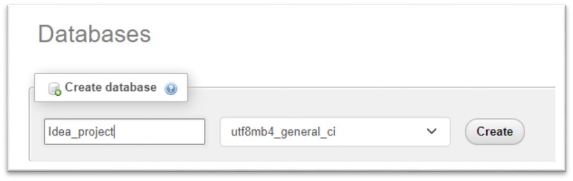

*Figure II.1 Create database*

This is explain create entities of table

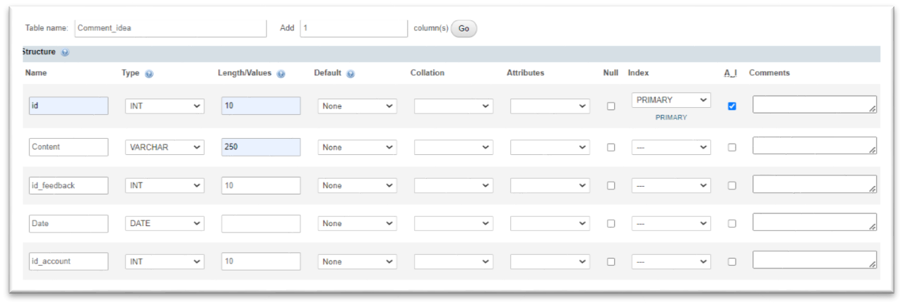

*Figure II.2 Create entities*

Command to connect to the database

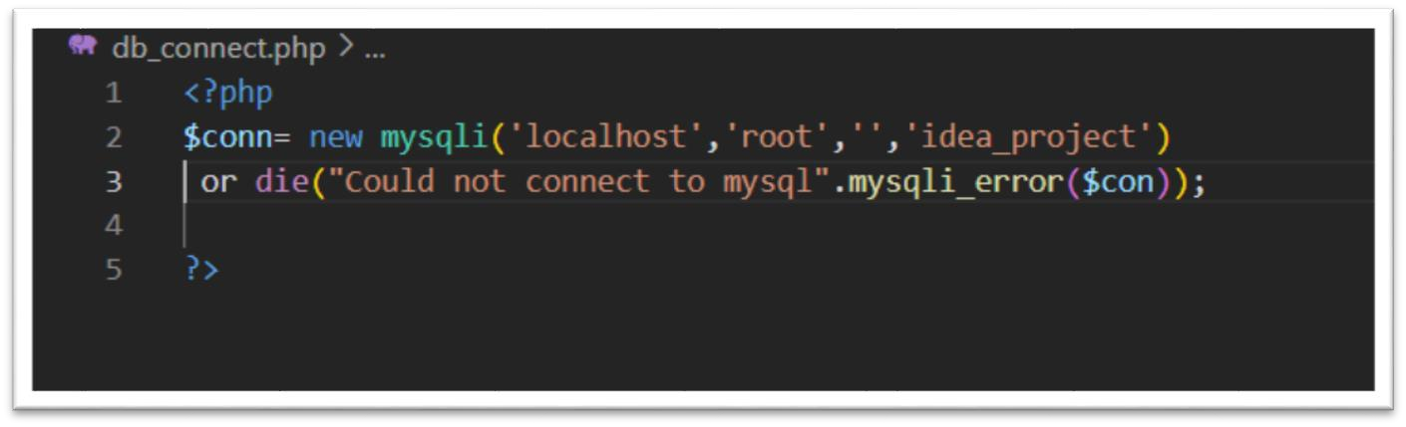

*Figure II.3 Connect database*

#### 1.2 User Interface

The "user-friendly interface" is designed to maximize user convenience, regardless of whether they are a specific group of people or not. The main goal of this interface is to give the user the best possible experience, with the hope that when using the website, the application, the user will feel satisfied and satisfied (V., 2021) . Our product emphasizes minimalism in user interface. By simply displaying essential information and using simple colors to avoid confusion for users, we ensure that users can access all functions without difficulty. in system navigation. However, this can give a rather smooth impression, not really eye-catching in terms of images. We realized that this potential weakness could impact the product, so we've reviewed and retested to find ways to improve the user experience more holistically.

In addition, the interface specific to titles such as QA and staff will be designed differently. Websites or apps for QA should show all the manageable functionality. However, the staff interface will only be limited to responding to QA posts. This allows employees to focus on their work without being distracted by unnecessary features and functions. We are researching and developing tools to ensure product quality and provide a great user experience.

This is explain interface after staff login successfully.

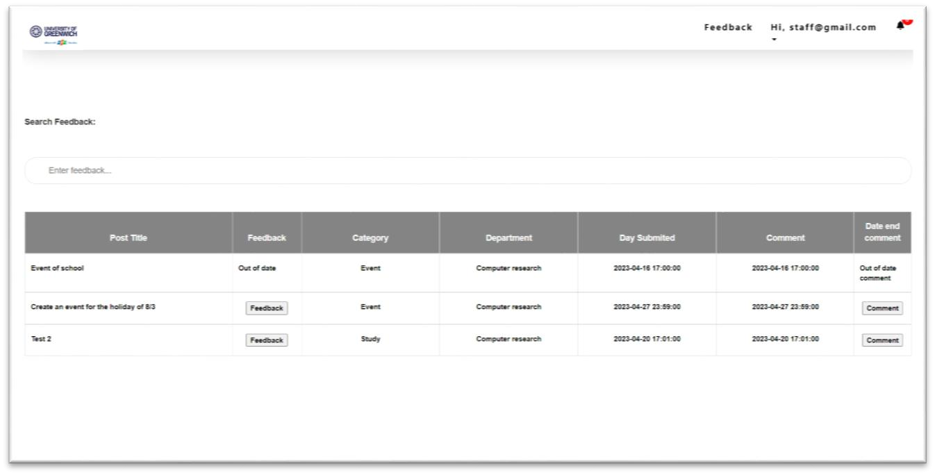

*Figure II.4 Interface after staff login successfully*

#### 1.3 Functions

Currently, we have completed about 90% of user requests related to basic functions on the system. These functions have been implemented and are working correctly and efficiently. However, there are still some functions that we have not completed, such as exporting files and optimizing the website for mobile platforms.

Our team focuses mainly on developing the website platform and ensuring that the implemented functions are working optimally. To help users better understand what functions are currently implemented on our website, we provide a detailed and comprehensive table below. Thereby, they can easily monitor and capture the operational status of each function.

We are committed to continuing to develop products professionally, meet user requirements, and improve user experience continuously.

**Table 4:** Function

|  |  |  |
| --- | --- | --- |
| **ID** | **Users** | **Functions** |
| 1 | Staff | Login/ logout to the website |
| View post and feedback |
| Update account |
| Change password |
| Like and comment feedback |
| 2 | QA/Admin | Login/logout to the website |
| Manage post (View, create, edit, delete) |
| Manage staff (View, create, edit, delete) |
| Manage department (View, create, edit, delete) |
| Manage category (View, create, edit, delete) |
| View, comment and like feedback |
|  |  | View QA List |

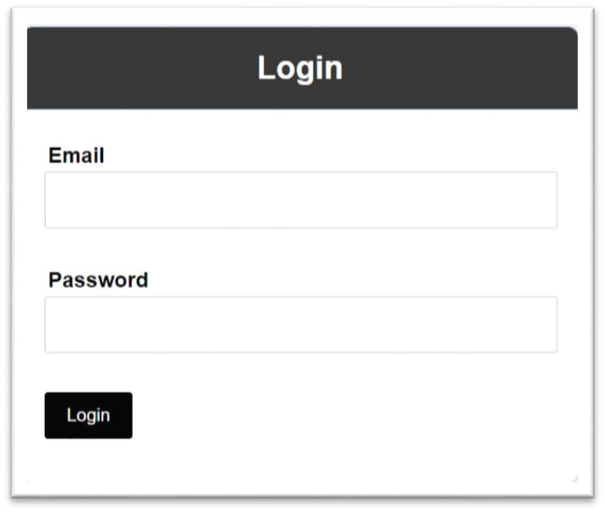

*Figure II.5 Function login*

### 2. Performance

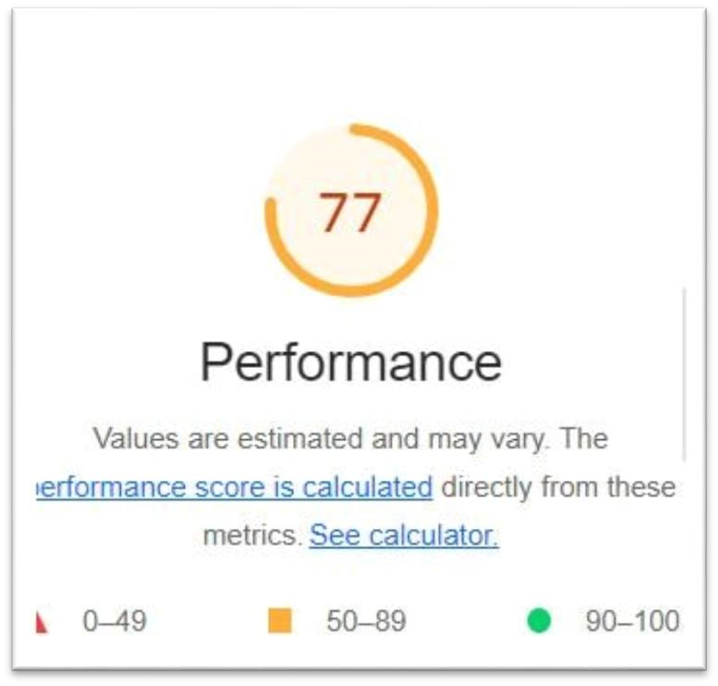

*Figure II.6 Performance*

**Explain:** Lighthouse is a free and open source program with the ability to measure website performance, features, and user experience. It is a very useful tool in improving from page loading speed to optimizing image quality. With Lighthouse, you can measure and track your website's performance scores across a variety of devices, from desktop to mobile. As such, using Lighthouse makes it easier for users to quickly assess the quality of their website and improve its performance.

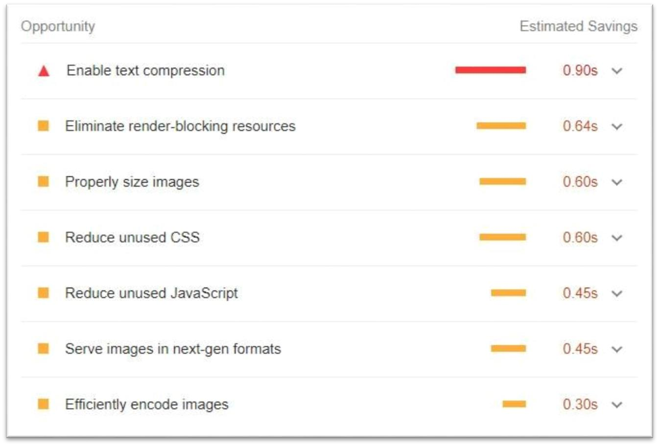

*Figure II.7 Improvements*

**Explain:** This program not only served its original purpose, but it also pointed out potential improvements for our website. We can therefore use these insightful suggestions to enhance our subsequent iteration.

#### 3. Development methodology – Agile Scrum

As I briefly mentioned in the Introduction, our team ultimately decided to use agile scrum. In more detail, Scrum is a methodology that can be employed to handle difficult adaptation problems while still being able to effectively and creatively produce high-value products when used. Here is a brief explanation of how our team used Agile Scrum principles to create this Idea Management System project.

Before beginning this Idea Management System project, our team's initial step was to discuss and precisely define each member's individual duties and responsibilities. The Product Owner role is specifically assumed by one team member, while the Development team will consist of the remaining team members.

My team generated the Product Backlog and Sprint Backlog for the Product Owner and made sure that the members of the Development team were aware of every item on it. The primary responsibilities of the Scrum Master are to support the Development team in producing high-value products and to remove obstacles in the way of that team's growth. Keeping track of and carrying out each individual job during the remainder of the Sprint is the Development team's primary responsibility. (Jeff Sutherland, 2014), (Cohn, 2005).

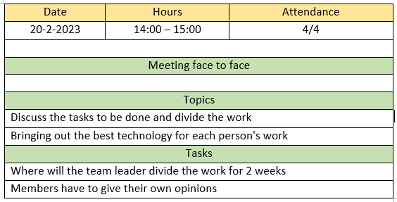

Figure III.1 Sprint 1

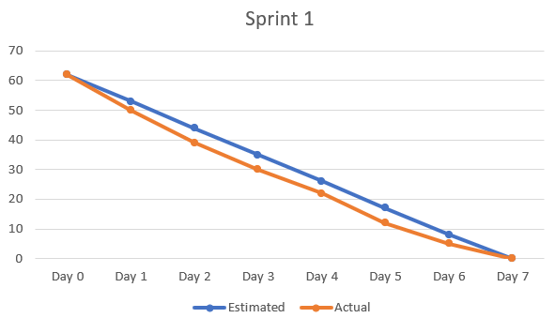

Figure III.2 Sprint 1.1

##### 2.1 Advantages

The projects without a detailed set of user requirements are appropriate for applying Agile Scrum. However, the Scrum Master actually introduced a few important needs during project implementation that were not included in the provided specification list. The first is that users of the Idea Management System must log in before they can access the system and carry out their tasks. Staff cannot undertake the duties of an Admin/QA Manager due to the system's decentralization feature. The main line is that if a traditional development approach like Waterfall is used, adjustments and re-prioritization in user demands may have some major repercussions.

On the other hand, in this circumstance, using Agile Scrum with adaptation and flexibility throughout the entire project implementation process will be quite helpful.

Our team only has roughly 2 and a half months to complete this project. Therefore, the core idea of Agile Scrum emphasizes finishing and delivering everything rather than planning and documenting. In fact, the majority of our team's efforts are going toward developing the Idea Management System software and establishing solutions that can be disseminated during each Sprint. As a result, the project's entire workload was finished on schedule.

Last but not least, there are 4 people on our team (including Team Members - Roles). The members of our team would work well on a Scrum team. In a big team like ours, communication might be difficult because the Scrum team largely relies on it. (Jeff Sutherland, 2014), (Cohn, 2005).

##### 2.2 Difficulties

In addition, the usage of Agile Scrum presents some challenges for the project's implementation of the Idea Management System. First and foremost, every Scrum team must have a Scrum Master, whose responsibility it is to help team members comprehend the principles, practices, and regulations of Scrum. As is clear, for this function and position, a team member must not only have a fundamental understanding of Scrum but also, and maybe more crucially, experience working on or leading projects utilizing Scrum as a development technique. However, it was not the case for our team because we were all novices at using Scrum in project development. So, this is a challenge we ran into when trying to implement Agile Scrum to this project.

The challenge is a result of another Scrum hallmark—the daily standing team meetings—which our team has run into often throughout the process. In essence, this is intended to take place every day at a specific time with involvement from every team member to present the tasks that have been completed and will be completed the following day. Our team members' varying schedules, however, prevented them from always being fully present. Additionally, this absence may result in a meeting's quality issues, such as unclear updates on each member's progress or the announcement of new plans.

Last but not least, because members of the development team are autonomous, committed, and not directly under the Scrum Master's control, being irresponsible can be challenging when it comes to trashing the work produced by other team members and may finally result in project standstill. As a result of our team's inability to completely commit to the project due to team members' varying schedules, this stagnation occurs when the workload is still very heavy despite the extremely limited amount of time left.

#### 4. Group work

##### 3.1 Self-assessment

In the process of doing the job, I chose 2 jobs: Database Designer and Tester. In my work as Database Designer, I will give presentations, impart understanding of databases, as well as learn and select the latest tools for optimal application for the project. As for Tester, I have created test scenarios to ensure that all the features of the application are working properly. I have to test each part of the application to make sure the feature is working properly and the bugs are resolved. I also had to make sure that the user interface was simple and easy to use.

At first, my knowledge about database designer and tester was quite limited, but in the process of working, with patience, I have learned from many websites, teachers and friends. These motivated me to do 2 more jobs. This is really a project that has given me a deeper understanding of database design and testers and made me love them more and know how to do and apply them to my project.

###### 3.1.1 Strength

In this project, the person responsible for the design of the database and tester is a person with an outstanding ability that is the ability to analyze and understand customer requirements. I know how to come up with the right database design solutions to meet the technical requirements and business conditions of the users. That cannot be achieved without using the latest technologies to deal with database design challenges. I have tried to learn and use specialized tools and software to create diagrams, diagrams or models that represent the structure accurately and clearly.

As a Tester, it is my responsibility to analyze the requirements and technical documents to better understand the features and functionality of the software under test. Then I need to design and develop a rigorous test plan, including programming test cases and evaluating test results. This process includes automated and manual testing of the software according to the planned schedule. In order to achieve the goal of effective testing, I need to generate a detailed report of the test results, including the detected defects and evaluate the quality of the software. It is very important to work closely with other members of the software development team to find and solve problems that occur during testing. A well-coordinated approach can help me and other team members figure out how to resolve bugs, limit duplication of work, and optimize the software development process.

###### 3.1.2 Weakness

Whether they are database designers or frontend developers, they are all talented experts in the field of technology. However, both also have their weaknesses alongside their strengths. With database designers, one of their common weaknesses is the lack of understanding of the client's needs. If they are not fully informed about the customer's requirements or cannot create a stable data model, their product may not work effectively or meet the needs of the customer.

Testers can get bored with the repetitive, time-consuming and demanding testing process. The software testing process often takes place in an iterative way, requiring testers to work in a limited space and focus on every little detail. This can make Testers feel bored and difficult to maintain productive work spirit.

##### 3.2 Evaluation of the team

###### 3.2.1 Vinh – Scrum master and Full stack

###### Strength

A good leader has a clear vision and direction for the team. He has the ability to think and analyze in detail and thoroughly, as well as use his knowledge to make accurate decisions on the project. It is important that he has the ability to interact effectively with team members, especially in building and maintaining healthy relationships with those in the group.

In addition, he has the ability to motivate, motivate and motivate team members, with his own words and actions leading. He must be able to gather talents and use them to solve complex problems and achieve the best results for his project.

#### Weakness

One of the weaknesses of a leader is a slight inability to listen to the opinions of team members. When he can't understand and respond to the needs and wants of the team members, he can create tension and dislike working in the team. A lack of honesty and connection with employees can also lead to distrust of leaders and affect organizational performance. And he has not yet created a really effective team working environment and given assertiveness in work to each member of the team.

##### 3.2.2 Quan - Tester and Frontend developer

##### Strength

His strengths are intelligence and sensitivity, especially in coming up with bold and interesting ideas for group projects. He proposes creative ideas and has a vision for user-friendly interfaces. This makes the projects developed more complete and easier to use for users. His genuine personality is also included in the projects, giving users a more secure and friendly feeling when using the products.

**Weakness**

However, his weakness is procrastination, which interrupts the completion of projects. He is often absent from team meetings to report on progress and this adversely affects the completion of projects. Although there are some objective reasons such as illness or family supporting the business, he needs to determine a more suitable time so as not to interrupt and affect team members. An effective work assignment plan and progress tracking will help you manage your time better.

##### 3.2.3 Phat - Product Owner and Tester

##### Strength

When taking on the position of Product Owner and Tester, you have the ability to plan and manage products. With this ability, you can build a detailed plan and make decisions that help the product, help the product develop successfully, and achieve the goals of the project.

The ability to test, evaluate the product, and find bugs is a strong point of an effective Tester and Product Owner. By promptly detecting and solving problems with your product, you can ensure product stability and reliability, and also critical thinking, mental health, and the ability to adapt to difficult situations in the product development process to help the product develop successfully and bring value to the team.

#### Weakness

A person taking the position of Product Owner and Tester may also encounter some weaknesses that are subjective product evaluations. If he does not evaluate the product objectively, it will be difficult to find the potential defects and strengths of the product, thereby offering suitable solutions and improving the product.

Poor time management is also a weakness that can affect the work of a person taking the position of Product Owner and Tester. If he is not able to manage his time effectively to complete the work on time, the number of defects in the product will increase, leading to a decrease in the performance of the team's success. besides there may be bad interaction with other members of the workgroup. If you do not have the ability to interact and support each other, it will cause difficulties in project implementation and development.

##### 3.3 Detailed analysis

**Table 5:** Detailed analysis

|  |  |  |  |  |
| --- | --- | --- | --- | --- |
| **Member** | **To Nhat Duy** | **Tran Quan Vinh** | **Nguyen**  **Huynh Hong Quan** | **Truong Van Phat** |
| ***Behavior (0 - 5)*** |  |  |  |  |
| Attendance | 3 | 5 | 3 | 5 |
| On time | 4 | 5 | 3 | 5 |
| There is a reason to be absent | 5 | 5 | 5 | 4 |
| Preparation | 5 | 5 | 4 | 3 |
| Complete mission | 3 | 4 | 2 | 5 |
| **Total (25)** | 20 | 24 | 17 | 22 |
|  | |  |  |  |
| ***Teamwork (0 - 5)*** |  |  |  |  |
| Spirit when participating in group discussions | 5 | 5 | 4 | 5 |
| Propose ideas | 4 | 4 | 5 | 4 |
| Attitude at work | 3 | 4 | 3 | 5 |
| Accept the strength of the group members | 5 | 5 | 5 | 3 |
| Does not affect the meeting | 4 | 5 | 3 | 4 |
| Accept feedback | 4 | 5 | 3 | 4 |
| Have a spirit for  teammates | 5 | 4 | 5 | 4 |
| Reputation at work | 3 | 4 | 3 | 5 |
| **Total(40)** | 33 | 36 | 31 | 34 |
|  | |  |  |  |
| ***Leadership (0 - 5)*** |  |  |  |  |
| Troubleshooting | 5 | 5 | 5 | 5 |
| Share responsibility | 4 | 4 | 4 | 4 |
| The resolution of  conflicts | 5 | 5 | 4 | 5 |
| Express an opinion | 4 | 3 | 3 | 4 |
| The spirit of encouragement | 3 | 4 | 4 | 5 |
| Support with camaraderie | 4 | 4 | 3 | 4 |
| The connection with each other | 4 | 5 | 3 | 4 |
| **Total (35)** | 29 | 30 | 26 | 31 |
|  | |  |  |  |
| ***Work Product (0-5)*** |  |  |  |  |
| Report has been resolved | 5 | 5 | 3 | 5 |
| 4Output meets original expectations | 4 | 4 | 4 | 4 |
| Successful submission of work | 4 | 5 | 5 | 5 |
| Professional writing work | 4 | 3 | 4 | 3 |
| The presentation is well rehearsed. | 5 | 5 | 4 | 4 |
| **Total(25)** | 22 | 22 | 20 | 21 |
|  | |  |  |  |
| ***Technical Expertise (0-***  ***5)*** |  |  |  |  |
| Share work for members | 5 | 5 | 4 | 5 |
| Self-help or technical troubleshooting | 4 | 4 | 3 | 4 |
| Work according to the required steps | 3 | 5 | 4 | 5 |
| Accurate statistics | 5 | 5 | 4 | 5 |
| **Total(20)** | **17** | **19** | **15** | **19** |
|  | | | | |
| **Overall Evaluation** |  | | | |
| The grade I will make for the contribution of the project. | **5.0** | **5.0** | **5.0** | **5.0** |
| The grade I think I'll get from other members. | **4.5** | **4.5** | **4.5** | **4.5** |
| Do you want to work with him (her) in the future? (Yes no). | **Yes** | **Yes** | **Yes** | **Yes** |
| Contributes to the project in terms of their relative importance (The total score of the member must be 100). | **24** | **20** | **29** | **27** |
| **Total** | **33.9** | **29.5** | **38.5** | **26.5** |

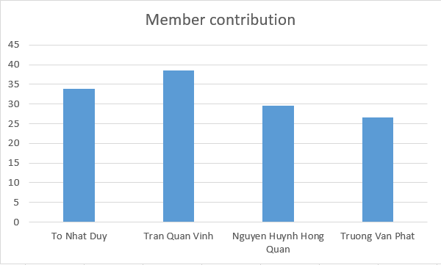

Figure III.3 Member contribution

# III. Improvements

I'm going to list a few errors and lessons learned that I discovered after using the Agile Scrum approach throughout the entire working process in this section.

### 3.1 Mistakes

#### 3.1.1 Nexperienced Database Designer and Tester

Lack of knowledge of Database Designer and Tester is one of the weaknesses that can affect the performance of a person in that position.

Lack of knowledge of Database Designer will make database design more difficult. If I do not have knowledge of how to design the underlying database or do not understand the relationships between the tables in the database, it will lead to the end product not meeting Really, I have to admit that I am not a professional Tester and there are some critical errors that keep happening during testing. However, I always try my best to fix those errors and learn from the experience to become a better Tester. During software testing, I cannot avoid missing some minor bugs. However, I have found that it is very important to report bugs and issues to other team members for timely remedial action. Starting from there, I learned how to improve my bug finding to ensure test accuracy, both during automated and manual testing.

So these basic skills are necessary for someone to take on the position of Database Designer and Tester like me. If I feel like I'm not knowledgeable enough, invest time and effort in learning to improve my skills. That way, you can create a higher quality product that meets the needs of your customers.

**3.1.2 Team members are not responsible or committed.**

Lack of responsibility at work is one of the weaknesses that can affect the performance of everyone on the team. If I do not take responsibility for my work, I will not be able to guarantee the progress of the work and the quality of the product to be achieved.

Lack of responsibility for work can also lead to failure of project goals. If I don't provide changes and continuous updates on progress and work plans, there will be disruptions in the product development process. This will prolong the working time and lead to poor teamwork.

Lack of responsibility also affects the alignment and interaction between members of the working team. If you don't motivate and carry out your own tasks, it will affect the completion of other members' tasks and reduce the effectiveness of the team's work.

#### 3.1.3 Others in the team lack basic knowledge

Lack of understanding of each team member is one of the weaknesses that can negatively affect the working process of the team. If members do not clearly understand how to work, their ability to contribute will be reduced and errors in communication and performance may occur.

Lack of understanding also makes it difficult to make accurate and optimal decisions for the product. If members do not clearly understand the ideas or goals of the project, it will be difficult to reach consensus and exchange ideas among team members. This can affect the ability to come up with a common solution for the project and cause disagreements about behavior and working process.

To avoid this situation, effective tools and methods can be used to enhance understanding among colleagues. For example, regular meetings, face-to-face communication, media events or even co-worker activities can help create real team communication.

In addition, teams need to focus on building an open and friendly work environment. When team members feel free to share their opinions, it's easier for them to create understanding and empathy. This increases the team's ability to achieve their goals and improve their performance.

### 3.2 Lessons learned

#### 3.2.1 Building strong relationships with other members

To create intimacy and sociability in a group, there are many valuable lessons to be learned. The first important thing is trust among team members. Each person needs to understand each other's abilities and capabilities, and feel secure when working together. Without trust, it will be difficult for members to interact and complete the project together.

Second, to create intimacy and harmony, members need to understand each other better. It is a negative experience to draw conclusions on your own, diagnosing the personality of a colleague. But a more detailed observation, listening, and empathy have helped the group to increase its attractiveness and make it easier for colleagues to give a lot of interesting ideas.

Communication is very important in creating friendliness and sociability. Members need to make sure that they not only understand each other, but also know how to support each other, helping each other when needed. If members get support and help from people they know, it will be easier for them to bond with each other.

Finally, it's also important to share a common goal. When team members are united in understanding their goals and future aspirations, they share a common purpose and a pervasive mindset. This will help create a relaxed atmosphere, strengthen unity and help the team work more effectively.

#### 3.2.2 Improving the database designer and tester knowledge

Improving your knowledge of Database Designer and Frontend Developer is an ongoing process and requires effort and perseverance to hone the skills.

For Database Designer, I can start by learning basic theory of relational databases and SQL language, and then study database management tools like MySQL, Oracle or MS SQL Server. You should improve your skills in database design, system design, data optimization, query programming and related techniques.

Improving knowledge for a Tester is extremely important to achieve greater efficiency in the software testing process. Testers need to keep learning and updating with the latest software engineering knowledge, tools and problem solving skills to better understand the software testing process and be able to give accurate feedback. and timely. There are many ways to improve the knowledge of a Tester. The first is to take training courses or online courses in software testing and related tools to master different technologies. In addition, diligently participate in software testing related information on specialized websites and forums to learn more about the latest trends in this field.

However, it's not enough just to learn theory, I need practice to hone my skills. I can start by doing simple projects, join workgroups, act as technical support staff and can participate in internship programs at companies. It's important to learn from the experiences of people who have actually worked in the field and stay up to date with the latest in technology. Plus, use simulation environments to put your skills to the test, improve your problem-solving abilities, and improve your computer skills.

# IV. Conclusion

After working for a while on the Idea Management System project, I would like to share my experience in the process. This was a challenging project where I was exposed to various issues in interface and functional design and applied Scrum in project development.

First of all, I find myself working in a very good and interesting team, whose members can support each other and work together to achieve common goals. Through that, I learned how to work with the Scrum method, and improved my database design and testing skills.

It was also a new challenge for me to take on new roles in a project that adopted a new development approach. However, my efforts paid off in finding a match between my roles and skills. At the same time, I also know which skills need to improve in the future to do better at my job.

To sum up, this Idea Management System project not only gave me a good and enjoyable working experience in a productive team, but also helped me to improve my skills and knowledge in the field. work and self-improvement.

# References

Cohn, M., 2005. *Agile Estimating and Planning.* 1st Edition ed. s.l.:Pearson; 1st edition.

Jeff Sutherland, J. S., 2014. *Scrum: The Art of Doing Twice the Work in Half the Time Hardcover.* Illustrated edition ed. s.l.:Currency; Illustrated edition.